**You have reefer cargo to be shipped. We have the solution and the expertise. Let us you explain you in a few words.**

A reefer container, also known as a refrigerated container, is a type of shipping container that is equipped with a built-in refrigeration unit to control the temperature and humidity of the cargo stored inside. These containers are specifically designed to transport goods that require temperature-controlled environments, such as perishable foods (like fruits, vegetables, fish, meat, wine & spirit and dairy products) and pharmaceuticals.

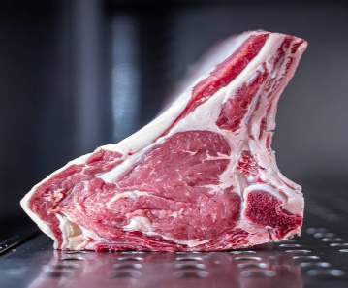



Reefer containers are crucial for maintaining the quality and safety of temperature-sensitive products during transit. The temperature inside the container can be adjusted to suit the specific requirements of the cargo, ensuring that it remains fresh and in optimal condition throughout its journey. The refrigeration system is powered by electricity, typically from the ship's power supply while at sea or from a generator when on land.

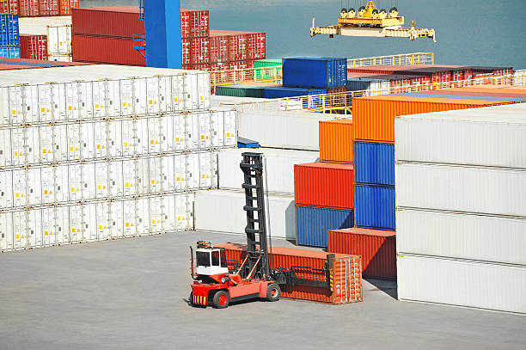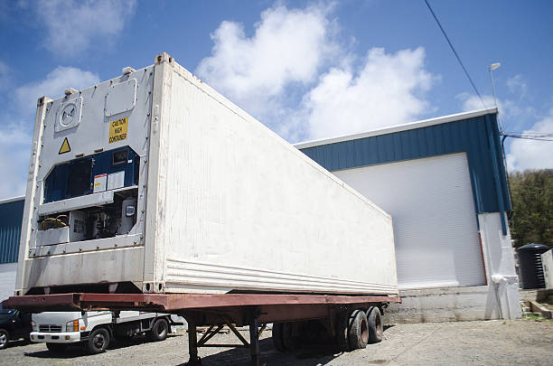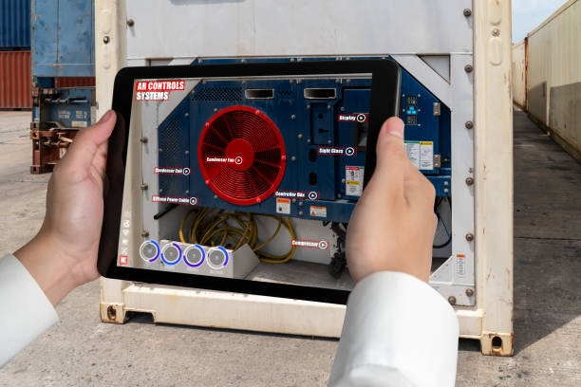

Key features of reefer containers include:

1. **Temperature Control :** Reefer containers can maintain temperatures within a specific range, typically ranging from -30°C to +30°C (-22°F to 86°F) or even more depending on the model. This makes them suitable for various types of perishable goods.
2. **Insulation :** Reefer containers are well-insulated to prevent temperature fluctuations and minimize heat exchange with the external environment.
3. **Humidity Control :** Some reefer containers also offer humidity control, which is important for products that are sensitive to moisture.
4. **Ventilation :** Controlled ventilation helps ensure proper airflow and temperature distribution throughout the container.
5. **Monitoring and Data Logging :** Modern reefer containers come equipped with advanced monitoring and tracking systems that allow shippers and logistics companies to remotely monitor the temperature and other conditions inside the container. This helps in real-time management and ensures the cargo's integrity.

Reefer containers play a critical role in global trade, allowing perishable goods to be transported across long distances while maintaining their quality. They are used in various modes of transportation, including ships, trains, and trucks, to move goods between different regions and countries.