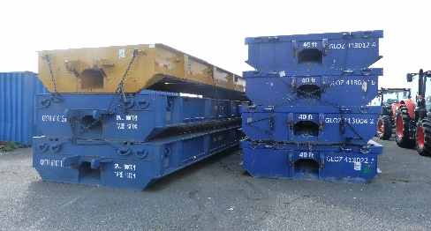

**MAFI TRAILER LOADING**

To load securely, we need first to assess the cargo. We need to check the size, weight, centre of gravity and stability of the unit. If it is loaded crated, the dimensions and weights should comply with carrier's restrictions. There are usually limits on the maximum height, width, length, and weight of the cargo.

Our third-party commitment at loading port is then to secure the crates on MAFI trailer. We will use high-quality and certified lashing equipment such as lashings straps, chains, twist locks, corner protectors and other means of securing the crates to prevent them from shifting during transport.

We can use as well some common techniques such as :

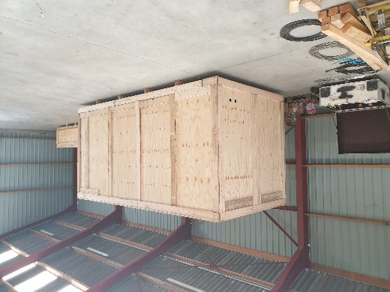Chock the cargo : Use wedges or chocks to prevent lateral movement of the cargo.

Overlapping lashings : Cross the lashings over the top of the cargo to provide a crisscross pattern, enhancing stability.

If the cargo is stacked or tiered, we use vertical lashings or additional supports to prevent it from collapsing or toppling over.

Block and brace : we utilize dunnage, such as wooden blocks or braces, to immobilize the cargo and prevent it from sliding or tipping.

We will ensure that the equipment is in good condition and capable of withstanding the forces exerted during transport.

With our updated calculation, we will distribute weight evenly in order to maintain stability. We will avoid overloading or placing too much weight on one side.

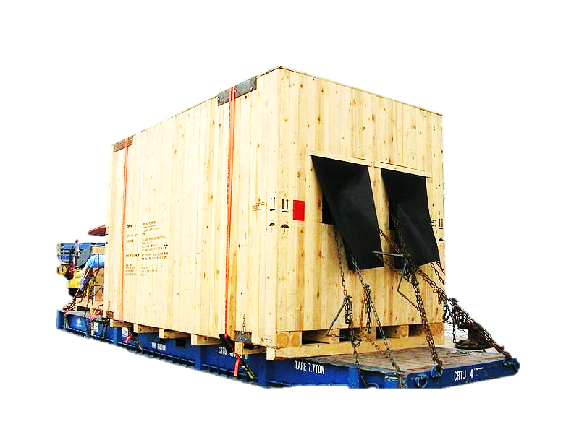To sum up for lashing & securing cargo on MAFI trailer, we have to follow the carrier's specific requirements. This includes the number of lashings needed, the type and strength of lashings permitted, and the angle at which they should be applied. Typically, lashings should be crossed and tightened to provide secure and balanced load distribution.

Purpose of the holes in the crates is to be followed as well. Holes are typically designed to serve specific functions such as ventilation, drainage, or accessibility for lifting or securing the cargo. We evaluate structural integrity of the holes in the crates. The presence of holes should not compromise the structural integrity of the crates. The holes should not weaken the overall strength or stability of the crate, especially if they are located near load-bearing areas or corners. If there are concerns about structural integrity, we shall reinforce the crate or consult the manufacturer for guidance.

